ROCA Volunteer Assignment

Batch 3 — Mobile Screen Specifications
Document | Value | Status
Version | v1.0 — Initial Release | DRAFT
Project | ROCA — Religious Organization Calendar App
Module | Volunteer Assignment Flow
Batch | Batch 3 (Screens 1–3)
Author | ROCA Design & Engineering Team
Date | 2025

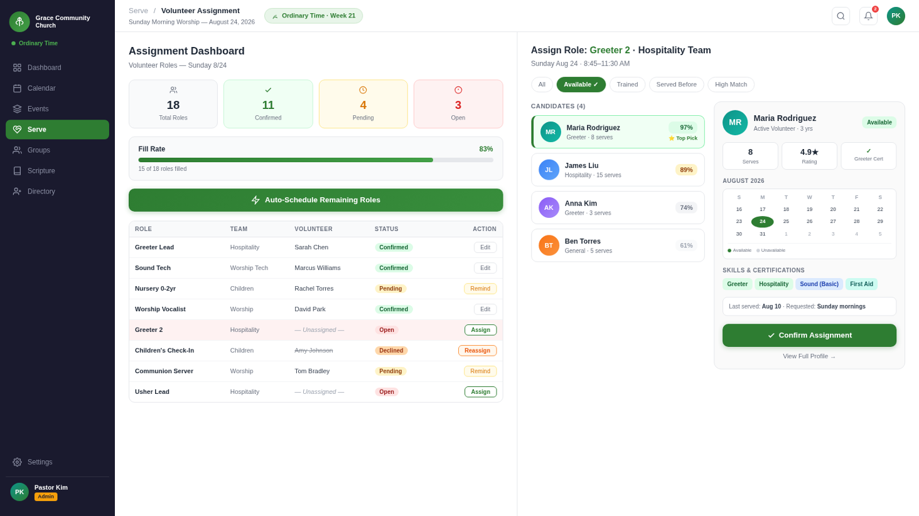
Figure 1 — ROCA Volunteer Assignment Mobile Screens (Batch 3): Invitation Received · Assignment Detail · Accept Confirmation

Document Overview
This specification document describes the three mobile screens that form the ROCA Volunteer Assignment flow (Batch 3). These screens guide a volunteer from receiving a push-notification invitation through reviewing their assignment details and confirming their acceptance. The document covers screen purpose, visual layout zones, user interaction patterns, and backend API endpoints for each screen.

Screen | Title | Primary Action
Screen 1 | Invitation Received | Accept / Decline
Screen 2 | Assignment Detail & Task Checklist | View Tasks / Progress
Screen 3 | Accept Confirmation | View Booking Ref

Design Principles
- Mobile-first: all screens optimised for 390×844 px (iPhone 15 Pro reference)
- Accessibility: WCAG 2.1 AA contrast, minimum 44 px tap targets
- Progressive disclosure: only essential information shown at each step
- Consistent green brand palette (#1A7A4A primary, #E8F5EE background)
- Real-time data: task progress and team info fetched on screen load

SCREEN 1
SCREEN 1 — INVITATION RECEIVED

1.1 Screen Purpose
The Invitation Received screen is delivered to the volunteer as both a push notification banner and a deep-linked in-app screen. Its purpose is to present an event invitation in a compelling, context-rich format that helps the volunteer make an informed accept/decline decision quickly. The screen highlights why the volunteer was selected, giving a personalised feel that increases acceptance rates.

1.2 Push Notification Specification
Attribute | Value / Behaviour
Trigger | Admin publishes event and selects volunteers via assignment wizard
Title | "You have been invited to volunteer!" — max 50 characters
Body | Event name + date/time, e.g. "Sunday Service — Aug 17, 9:00 AM"
Action Buttons | "Accept" (primary green) and "Decline" (secondary gray) — iOS & Android lock-screen actions
Deep Link | roca://volunteer/invitation/{invitationId} — opens Screen 1 directly
Expiry | Notification expires 48 h after delivery; banner auto-dismisses in 5 s
Badge | App icon badge increments by 1 per unread invitation

1.3 Layout Zones
Zone | Component | Description
Z-01 Header | Navigation bar | Back arrow, "Invitation" title (centered), notification bell icon (top-right)
Z-02 Event Card | Hero image + event meta | Event cover photo (full-width 390×180 px), event name (24 pt bold), date, time, location on card beneath
Z-03 Why Selected | Personalised panel | Heading "Why you were chosen", skill tags (chips), past-service count badge
Z-04 Event Details | Detail list rows | Icon rows for: team leader name, expected volunteers count, role/ministry, dress code, preparation notes
Z-05 CTA Bar | Sticky bottom action bar | Full-width "Accept" button (green #1A7A4A), "Decline" text link; fixed at bottom with safe-area padding

1.4 Interactions
Interaction | Trigger | Behaviour
Accept Tap | Tap "Accept" CTA | POST to /api/invitations/{id}/accept — navigate to Screen 3 (confirmation) on success; show toast on error
Decline Tap | Tap "Decline" link | Shows bottom-sheet modal with optional decline reason field; POST to /api/invitations/{id}/decline; returns to dashboard
Event Card Expand | Tap event cover photo | Opens full-screen image lightbox with pinch-to-zoom
Skill Tag Tap | Tap skill chip in Z-03 | Tooltip popup describing how skill relates to the event role
Share | Long-press event card | Native iOS/Android share sheet — share event link (not the invitation)
Swipe Down | Full-screen swipe-down gesture | Dismisses screen and returns to previous route (same as back arrow)

1.5 API Endpoints
Method | Endpoint | Auth | Description
GET | /invitations/{id} | Bearer JWT | Fetch full invitation details: event meta, why-selected reasons, team info, role description
POST | /invitations/{id}/accept | Bearer JWT | Accept the invitation; creates an Assignment record; triggers confirmation push notification
POST | /invitations/{id}/decline | Bearer JWT | Decline with optional { reason: string }; marks invitation as declined; notifies admin
GET | /events/{eventId} | Bearer JWT | Fetch event cover photo URL, full description, location coordinates for map preview

SCREEN 2 — ASSIGNMENT DETAIL & TASK CHECKLIST

2.1 Screen Purpose
The Assignment Detail screen gives the accepted volunteer a complete operational briefing: who is on their team, what tasks they are responsible for, and their real-time progress toward completion. A visual progress bar provides at-a-glance motivation, while the 6-item task checklist allows the volunteer to track their individual responsibilities from preparation through post-event wrap-up.

2.2 Team Panel
Element | Detail
Team Leader | Avatar (40 px circle), full name, role label "Team Leader" in green badge, tap-to-call shortcut
Team Members | Horizontal avatar stack (up to 5 visible + "+N more" chip); each avatar shows online/offline dot indicator
Ministry Tag | Pill chip showing ministry name, e.g. "Worship Team", "Ushers", "Media & Tech"
Group Chat CTA | Icon-button "Message Team" opens in-app group chat thread pre-populated with event context

2.3 Progress Bar
Attribute | Specification
Component | Full-width horizontal bar (8 px height, rounded caps), below team panel, above checklist
Fill Colour | Green gradient #1A7A4A → #34C97A; empty track is #E0E0E0
Label | "X of 6 tasks completed" — updates live on task toggle without page reload
Completion State | At 6/6: bar turns solid gold (#F5A623), "All Tasks Complete!" label, confetti micro-animation fires
Accessibility | ARIA role="progressbar" with aria-valuenow, aria-valuemin=0, aria-valuemax=6

2.4 Task Checklist — 6 Tasks with States
# | Task Name | State | Description & Behaviour
1 | Pre-Event Preparation | Completed ✅ | Review event brief document; checkbox pre-ticked (green); strike-through label; read-only
2 | Attend Briefing | In Progress ⏳ | 30-min team briefing session; pulsing blue border animation; countdown timer badge shows time until briefing
3 | Setup & Equipment Check | Pending ○ | Arrive 45 min early; check equipment list sub-items; expandable row shows nested checklist of 3 equipment items
4 | Serve During Event | Pending ○ | Primary service duty; locked until briefing (T-2) is marked complete; lock icon shown with tooltip
5 | Post-Event Wrap-Up | Pending ○ | Equipment storage, cleaning duties; locked until Task 4 complete; depends-on badge shown
6 | Submit Feedback Report | Locked 🔒 | Short 5-question form; unlocks after event end time passes; auto-reminder push notification sent 1 h post-event

2.5 Task State Definitions
State | Visual Indicator | Behaviour
Completed | Green filled circle + checkmark | Row struck through, green background tint; PATCH /tasks/{id} called with status=completed on toggle
In Progress | Pulsing blue ring animation | Editable, no strike-through; auto-set when countdown reaches T-0
Pending | Empty circle, orange accent | Tappable if dependencies met; haptic feedback on toggle (iOS Taptic Engine, Android vibrate)
Locked | Padlock icon, gray text | Non-interactive; tooltip explains unlock condition on long-press

2.6 Layout Zones
Zone | Component | Description
Z-01 Header | Nav bar | Back arrow, "My Assignment" title, share icon
Z-02 Event Summary | Compact event card | Event name, date/time, location in condensed 3-row layout; thumbnail avatar
Z-03 Team Panel | Avatar row + CTA | Team leader + member avatars, ministry tag, message-team button
Z-04 Progress Bar | Progress indicator | Visual completion bar with label; sticky below team panel on scroll
Z-05 Task List | Scrollable checklist | 6 task rows; expandable for sub-tasks; swipe-right to mark complete
Z-06 Footer CTA | Sticky action bar | "View Event Details" secondary button + calendar add shortcut

2.7 Interactions
Interaction | Trigger | Behaviour
Toggle Task Complete | Tap checkbox | Optimistic UI update; PATCH /tasks/{id} {status: "completed"}; progress bar animates; confetti at 6/6
Expand Task | Tap task row chevron | Accordion expands sub-checklist items; height animates 300 ms ease-out
Swipe to Complete | Swipe task row right | Reveals green confirm strip; release past 60% threshold marks task complete
Message Team | Tap message icon | GET /assignments/{id}/chat to get thread ID; navigates to in-app chat
Add to Calendar | Tap calendar icon | Calls native OS calendar API to create event; no server call needed

2.8 API Endpoints
Method | Endpoint | Auth | Description
GET | /assignments/{id} | Bearer JWT | Full assignment detail: event, role, team, all 6 tasks with current state
GET | /assignments/{id}/team | Bearer JWT | Team members list with presence indicators and contact info
PATCH | /tasks/{taskId} | Bearer JWT | Update task status {status: "completed"|"pending"|"in_progress"}; validates dependency chain
GET | /assignments/{id}/progress | Bearer JWT | Returns {completed: N, total: 6, percentage: N} for progress bar; WebSocket subscription available
GET | /assignments/{id}/chat | Bearer JWT | Returns chat thread ID for the assignment team group; creates thread if not exists

SCREEN 3 — ACCEPT CONFIRMATION

3.1 Screen Purpose
The Accept Confirmation screen is the emotional high-point of the volunteer assignment journey. Triggered immediately after the volunteer taps "Accept" on Screen 1, it provides a celebratory moment that affirms their decision, delivers a unique booking reference for event day check-in, and arms them with clear next steps so they feel prepared and valued before they ever leave this screen.

3.2 Celebration Animation
Element | Specification
Confetti Burst | Full-screen confetti particle animation (Lottie JSON); 120 particles in brand colors (green, gold, white); 2.5 s duration; does not repeat
Success Icon | Animated checkmark SVG (stroke draws in 600 ms); 80 px diameter; green circle background #1A7A4A; scales from 0 to 1 with spring easing
Heading Text | "You're In!" — 32 pt bold; fades in at 400 ms after icon; primary green color
Subheading | "Thank you for serving, [First Name]. See you on [Date]!" — personalised via API response data
Haptic | iOS: UINotificationFeedbackGenerator(.success); Android: VibrationEffect.createWaveform([0,50,80,50])

3.3 Booking Reference Panel
Element | Specification
Reference Format | ROCA-{YYMMDD}-{6-char alphanumeric} e.g. "ROCA-250817-A4X9K2" — uppercase monospace font (SF Mono / Roboto Mono)
Panel Background | Dashed-border card (#1A7A4A dashes), light green fill #E8F5EE; mimics paper ticket aesthetic
Copy Button | Inline "Copy" icon-button beside reference; copies to clipboard; shows "Copied!" toast for 2 s
QR Code | 128×128 px QR code encoding the booking reference; displayed below text ref; tappable to enlarge to 300×300 px
Share | "Share Reference" button opens native share sheet with pre-filled text: "My ROCA volunteer ref: {ref}"

3.4 Layout Zones
Zone | Component | Description
Z-01 Animation Canvas | Full-screen Lottie overlay | Confetti plays over the entire screen for 2.5 s then dissolves; pointer-events: none so taps pass through
Z-02 Hero | Checkmark + heading | Centred success icon, "You're In!" heading, personalised subheading with volunteer name and event date
Z-03 Booking Ref | Ticket card | Reference code, QR code, copy and share actions; dashed-border ticket style
Z-04 Event Summary | Compact event info | Event name, date, time, venue — read-only summary strip
Z-05 Next Steps | Numbered action list | 3–4 numbered steps with icons: Review Assignment, Set Reminder, Message Team, Invite a Friend
Z-06 Action Bar | Sticky footer buttons | "View My Assignment" primary button (navigates to Screen 2), "Back to Dashboard" text link

3.5 Next Steps Panel — Detail
The Next Steps panel guides the volunteer through four post-acceptance actions, each with a tappable row that deep-links to the relevant feature:

# | Step | Behaviour
1 | Review Your Assignment | Navigates to Screen 2 (Assignment Detail); highlighted if tasks are still at 0% progress
2 | Set Event Reminder | Opens OS reminder/alarm sheet pre-filled with event date/time minus 1 h; no server call
3 | Message Your Team | GET /assignments/{id}/chat — opens team group chat thread pre-loaded with welcome message
4 | Invite a Friend | Generates shareable deep-link roca://events/{eventId}/invite; opens native share sheet

3.6 Interactions
Interaction | Trigger | Behaviour
View Assignment | Tap primary CTA | Navigate to Screen 2 via push transition; no new API call (assignment data already loaded)
Copy Reference | Tap copy icon | Write to system clipboard; show "Copied!" inline toast; no API call
Enlarge QR | Tap QR code | Modal overlay with 300×300 px QR code and "Show at check-in" instruction
Set Reminder | Tap step 2 row | OS reminder API call; confirmation snackbar "Reminder set for [time]"
Dismiss Screen | Back arrow or swipe down | Pops to dashboard; does NOT cancel acceptance (already committed server-side)

3.7 API Endpoints
Method | Endpoint | Auth | Description
GET | /invitations/{id}/confirmation | Bearer JWT | Returns booking reference, QR code data URL, personalised message tokens, assignment ID
GET | /assignments/{id}/chat | Bearer JWT | Returns or creates team chat thread ID for message-team next-step
POST | /events/{id}/invite-link | Bearer JWT | Generates a shareable invitation deep-link with UTM tracking for the invite-a-friend step

4.0 Technical Reference & Appendix

4.1 Complete API Summary
All API calls use HTTPS with Bearer JWT authentication. Base URL: https://api.roca.app/v1. All responses follow the ROCA standard envelope format {data: ..., meta: {...}, errors: [...]}.

Scr | Method | Endpoint | Auth | Purpose
1 | GET | /invitations/{id} | JWT | Fetch invitation details
1 | POST | /invitations/{id}/accept | JWT | Accept invitation, create assignment
1 | POST | /invitations/{id}/decline | JWT | Decline with optional reason
1 | GET | /events/{eventId} | JWT | Event cover photo + description
2 | GET | /assignments/{id} | JWT | Full assignment + task list
2 | GET | /assignments/{id}/team | JWT | Team members + presence
2 | PATCH | /tasks/{taskId} | JWT | Update task status
2 | GET | /assignments/{id}/progress | JWT | Progress bar data
2 | GET | /assignments/{id}/chat | JWT | Team chat thread ID
3 | GET | /invitations/{id}/confirmation | JWT | Booking ref + QR + tokens
3 | POST | /events/{id}/invite-link | JWT | Shareable invite deep-link

4.2 Navigation Flow Diagram
The three screens form a linear acceptance funnel with one branch for decline:

Push Notification  SCREEN 1 | → | Accept Confirmation  SCREEN 3 | → | Assignment Detail  SCREEN 2 | ↓ Decline  Dashboard

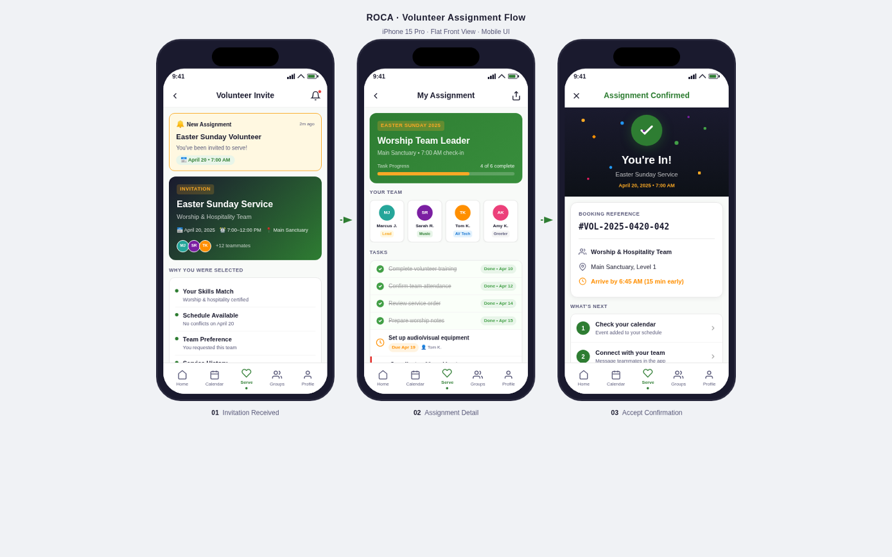
Figure 2 — ROCA Volunteer Assignment Mobile Flow: detailed interaction states and transitions across all three screens

4.3 Design Tokens Reference
Token Name | Value | Usage
color.brand.primary | #1A7A4A | Primary buttons, active states, headings, progress bar fill
color.brand.primaryLight | #E8F5EE | Card backgrounds, tag fills, info box backgrounds
color.brand.accent | #34C97A | Progress bar gradient end, success states
color.status.completed | #1A7A4A | Completed task checkmark and row tint
color.status.inProgress | #1A5C6E | In-progress task ring animation
color.status.pending | #E07B20 | Pending task indicator, warning accents
color.status.locked | #9E9E9E | Locked task text and padlock icon
color.celebration | #6B3FA0 | Confirmation screen header bar
spacing.base | 8 px | Base spacing unit; all margins/paddings are multiples of 8
radius.card | 12 px | Card corner radius; task rows use 8 px
font.size.heading | 24 pt | Screen section headings within the app
font.size.body | 15 pt | Body text, task labels, detail rows

4.4 Accessibility Checklist
Requirement | Implementation | Screen(s)
Min touch target 44×44 px | All buttons and checkboxes padded to minimum target | All
WCAG AA contrast 4.5:1 | Green #1A7A4A on white = 7.2:1; tested in Figma | All
Screen reader labels | accessibilityLabel on all icon buttons and imagery | All
Progress bar ARIA | role=progressbar, aria-valuenow, aria-valuemin/max | Screen 2
Animation reduce-motion | Confetti + checkmark disabled if prefers-reduced-motion | Screen 3
Dynamic type support | All text uses scalable sp/em units; layout reflows at 200% text size | All

Revision History
- v1.0 (2025) — Initial Batch 3 specification: Screens 1, 2, 3 defined
- Pending v1.1 — Add error state screens (network failure, expired invitation)
- Pending v1.2 — Add admin view: volunteer acceptance dashboard

